Name ________________________ pd.____ date_________ |  | Name ________________________ pd____ date__________
Pattern #1  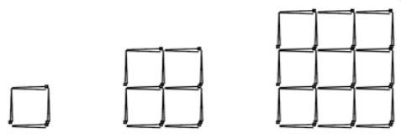  - Sketch the next step below.  - Draw a quick sketch of step 27.  - Complete this table.  Step n # of ___________________  1  2  3  4  5  10  27  - Write the equation. |  | Pattern #2  - Sketch the next two steps below.  2. Draw a quick sketch of step 27.  3. Complete this table.  Step n # of _______________  1  2  3  4  5  10  27  4. Write the equation:
Name ________________________ pd.____ date_________
Pattern #2
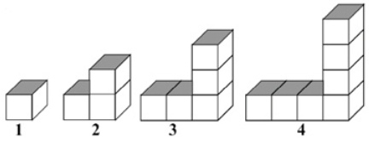

- Sketch the next step below.

- Draw a quick sketch of step 27.

- Complete this table.

Step n | # of ___________________
1
2
3
4
5
10
27

- Write the equation.

Name ________________________ pd.____ date__________
Pattern #3
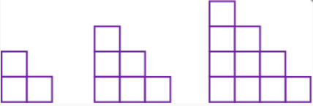

- Sketch the next step below.

- Draw a quick sketch of step 27.

- Complete this table.

Step n | # of ___________________
1
2
3
4
5
10
27

- Write the equation.

Name ________________________ pd.____ date__________
Pattern #4
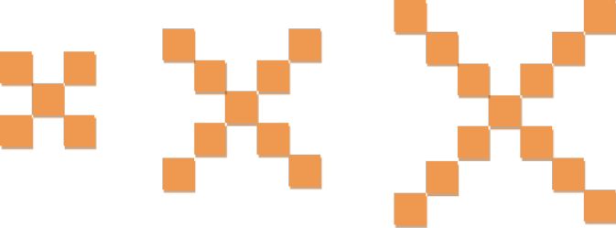

- Sketch the next step below.

- Draw a quick sketch of step 27.

- Complete this table.

Step n | # of ___________________
1
2
3
4
5
10
27

- Write the equation.

Name ________________________ pd.____ date__________
Pattern #5
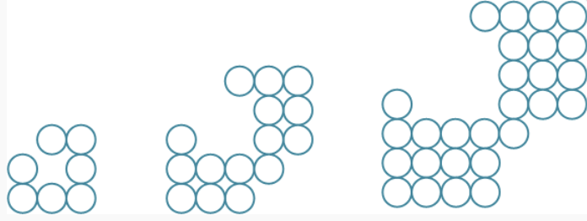

- Sketch the next step below.

- Draw a quick sketch of step 27.

- Complete this table.

Step n | # of ___________________
1
2
3
4
5
10
27

- Write the equation.
Name ________________________ pd.____ date__________
Pattern #6
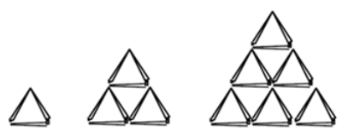

- Sketch the next step below.

- Draw a quick sketch of step 27.

- Complete this table.

Step n | # of ___________________
1
2
3
4
5
10
27

- Write the equation.
Name ________________________ pd.____ date__________
Pattern #7
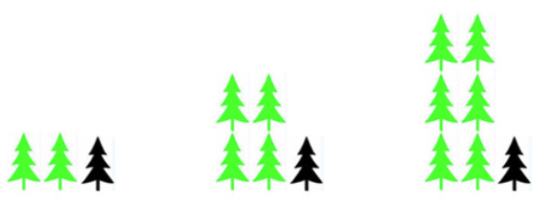
- Sketch the next step below.

- Draw a quick sketch of step 27.

- Complete this table.

Step n | # of ___________________
1
2
3
4
5
10
27

- Write the equation.
Name ________________________ pd.____ date__________
Pattern #8
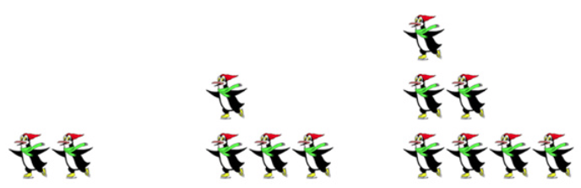
- Sketch the next step below.

- Draw a quick sketch of step 27.

- Complete this table.

Step n | # of ___________________
1
2
3
4
5
10
27

- Write the equation.
Name ________________________ pd.____ date__________
Pattern #9
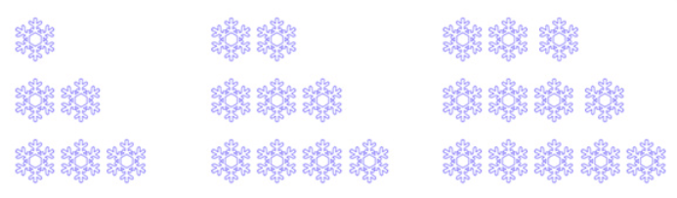
- Sketch the next step below.

- Draw a quick sketch of step 27.

- Complete this table.

Step n | # of ___________________
1
2
3
4
5
10
27

- Write the equation.
Name ________________________ pd.____ date__________
Pattern #10
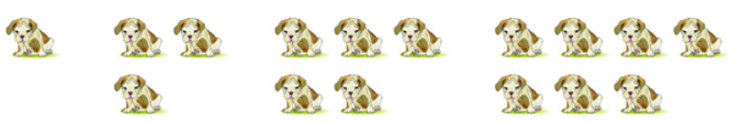

- Sketch the next step below.

- Draw a quick sketch of step 27.

- Complete this table.

Step n | # of ___________________
1
2
3
4
5
10
27

- Write the equation.
Name ________________________ pd.____ date__________
Pattern #11
- Sketch the next step below.

- Draw a quick sketch of step 27.

- Complete this table.

Step n | # of ___________________
1
2
3
4
5
10
27

- Write the equation.

Name ________________________ pd.____ date__________
Pattern #12
- Sketch the next step below.

- Draw a quick sketch of step 27.

- Complete this table.

Step n | # of ___________________
1
2
3
4
5
10
27

- Write the equation.

